**Project Design Phase -1**

**Solution Architecture**

|  |  |
| --- | --- |
| Date | 21 October 2023 |
| Team ID | NM2023TMID01674 |
| Project Name | Vaccine Tracking - Transparent |
| Maximum Marks | 4 Marks |

**Solution Architecture :**

Solution architecture is a complex process- with many sub-processes- that bridges the gap between business problems and technology solutions. Its goals are to :

* Find the best tech solution to solve existing business problems.
* Describe the structure, characteristics, behaviour, and other aspects of the software to project stakeholders.
* Define features, development phases, and solution requirements.
* Provide specifications according to which the solution is defined, managed, and delivered.

Example- Solution Architecture diagram :

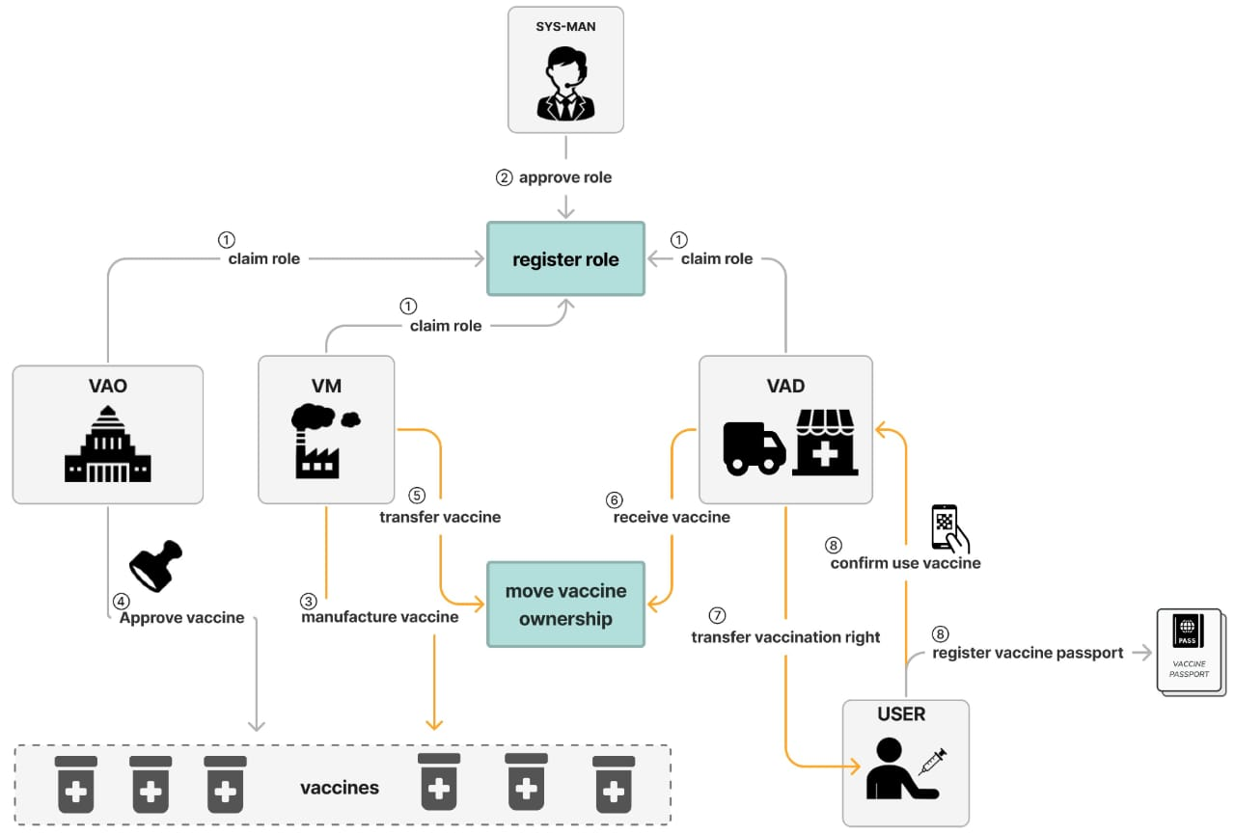

Figure 1: Architectutre of vaccine Tracking- Transparent